
MAIN TITLE
[Times New Roman 14 point, bold, centred, and Upper Case]

Author Name(s) [Times New Roman, 12 point, bold, centred and Upper and lower case]

Affiliation [12 point, normal, centred and upper and lower case]

City, Country [12 point, normal, centred and upper and lower case]

E-mail [12 point, italic, centred and upper and lower case]
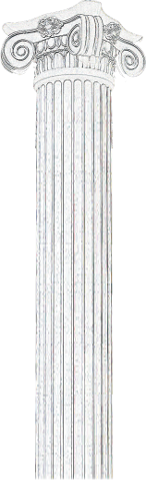

Abstract [Times New Roman 10-point, bold, centred and upper and lower case] [Times New Roman 10-point, italic, upper and lower case and alignment justified] A structured summary, which encapsulate the principal subjects covered by the paper which will be used for indexing. The summary should be understandable to readers who have not read the rest of the paper.

Keywords [Times New Roman, 10-point, bold, Alignment left] [Times New Roman, 10-point, normal, upper and lower case and alignment left].

JEL (Journal of Economic Literature):
Manuscripts should be typed on pages of uniform size using 1.5 spacing with 10-point interlining spacing, font Times New Roman (12). The margins should top – 2.5 cm; bottom - 2.5 cm; left - 2.5 cm; right - 2.5 cm. All the text must be in one column format and Times New Roman must be used, including figures and tables. Leave one blank lines before the sections.

- SECTIONS AND SUBSECTIONS
An article may be divided into sections, subsections, and sub-subsections, using Arabic numerals. Only the initial word and proper names should be capitalized.
Example:
1. Introduction
1.1. Public affairs
1.1.1. Corporate consultancy

- REFERENCES, FIGURES AND TABLES

The citation number of a bibliographical reference in text must be Harvard style (https://librarydevelopment.group.shef.ac.uk/Assets/pdfs/referencing/harvard.pdf ).

The number of the table, graphic or figure will be presented in italics, before the name of the item, both aligned to the center. The name of the item will be presented in bold, using the same font as the rest of the text, and placed on the top of the table, graphic or figure. The bibliographic source (when existing) will be centered and placed below the figure, table or graphic, centered, 10pt. The font of the tables will be the same of the entire text.
A list of the references should be given at the end of the paper.

Figures, tables and graphics should be centred, numbered and accompanied by a legend. (Fig.1. Legend, Table 1. Legend)

Please, avoid using page numbers, headers and footnotes.

References [Times New Roman, 10-point, bold, left and capitalize the first letter]

This template will assist you in formatting your paper. Please, copy it on your computer and insert the text keeping the format indicated

https://www.aeaweb.org/econlit/jelCodes.php?view=jel

